 | 28.1 Asset Browser – Default Asset Library
Table of content
Introduction 4
The Asset Browser Library 5
Library Contents 5
Categories 5
Simple Usage 6
Preparation 6
Loading Assets 7
Preferences 8
Instructions 8
Library Management 9
Remove Libraries 9
Re-add Libraries 9
Library Information 9
Location 9
Active Libraries 9
Status 9
Wizards 9
Triggering the Wizard 9
Using the Sidebar to change asset properties 10
Open Asset Wizard 10
Modifier Name 10
Modifier Properties 10
Default Library 11
Collections - Lights 11
Collections – Static Meshes 12
Backgrounds 13
Utility 13
Curve 13
Grease Pencil 13
Materials 13
Ceramic 14
Clay 14
Fabric 14
Foliage 14
Glass 14
Liquid 14
Metal 14
Miscellaneous 14
Paint 14
Plaster 14
Plastic 14
Rubber 14
Templates 14
Utility 14
Wood 15
Shader Nodegroups 15
Color 15
(Vector) Mapping 15
Masks 16
Patterns 16
Shader 17
Shapes 17
Utility 17
Geometry Nodes Library 18
Grease Pencil 18
Operations 18
Delete Empty Layers 18
Read 18
Layer Size 18
Material Fill info 18
Stroke Info 18
Write 18
Set Screenspace Radius 18
Set Stroke Softness 18
Set Stroke/Fill Color 18
Set Stroke/Fill Opacity 19
Materials 19
Inherit Material 19
Source Geometry 19
Target Geometry 19
Material Index 19
Mesh 19
Mesh Lines and Silhouette 19
Screenspace Radius 19
Overall Width 19
Variation 20
Randomization 20
Factor 20
Scale / Detail / Lacunarity / Distortion / Roughness 20
Weight Map 20
Vertex Group 20
Offset 20
Inner Lines 20
Width 20
Silhouette 20
Width 20
Flatten Factor 20
Camera Offset 20
Polygonize 20
Factor 20
Intersections 20
Width Offest 20
Object 21
Use a Collection 21
Collection 21
Weight Map Override 21
Factor 21
Color 21
Silhouette Color 21
Inner Lines Color 21
Use Silhouette Color 21
Material Override 21
Line Override 21
Silhouette Override 21
Normals 21
Blend Normals by Proximity 22
Use 22
Target Collection 22
Apply Blend to Materials 22
Use Relative Position 22
Enable Bounds Display 22
Modifier Properties 23
Target Collection 23
Normal Distance 23
Blending Iterations 23
Relative Position 23
Quality 23
Material Blend 23
Strength 23
Offset 23
Debug Intersections 23
Noise 24
Scale 24
Intersection Displacement 24
Distance 24
Offset 24
Blur 24
Iterations 24
Weight 24
Normal Blur 24
Iterations 24
Weight 24
Material Override 24
Material 24
Inherit Material 24
Info 25
Inherit Smoothness 25
Source Geometry 25
Target Geometry 25
Primitives 25
Use 26
Using the Gizmos 26
Using the Sidebar and Modifier properties 26
Top-Level Properties 26
Bevel Properties 26
Resolution Properties 26
UV Properties 26
Basic Shapes 27
Cube 27
Cube Rounded 27
Sphere 27
Icosphere 27
Cone 27
Cone Rounded 27
Cylinder 27
Cylinder Rounded 27
Tube 27
Tube Rounded 27
Advanced Forms 27
Capsule 27
Capsule Revolved 27
Grid 28
Torus 28
Torus Revolved 28
Spiral 28
Circle 28
Circle Revolved 28
Curve Lofted 28
Cylinder Revolved 28
Cylinder Rounded Revolved 28
Tube Revolved 28
Tube Rounded Revolved 28
Cone Rounded Revolved 28
Sphere Revolved 28

Introduction
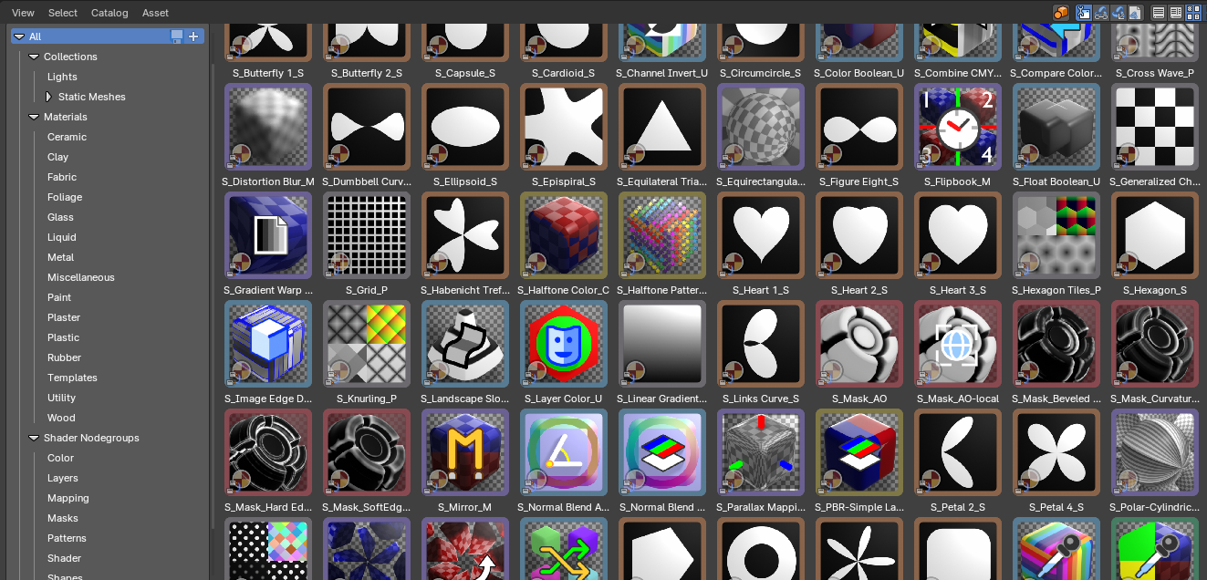
Bforartists comes with a default asset library – registered by addon. This is enabled by default. With this asset library you can find numerous default assets to get you up and running with your art quickly and efficiently.

The Asset Browser Library
The Asset Browser is an editor in the Asset Workspace that gives you some standard lighting settings for the Cycles and Eevee renderer, obects in collections, node groups, materials and more. It contains for example the classical three-point setup. But also some basic volumetrics examples – or a shader ball or color checker reference stand.
The default library addon can be turned off in the User Preferences.
Note that the Eevee light setup is rudimentary. Eevee is a realtime render engine. To achieve more realistic results you may want to use Light probes, and bake the lights and shadows. This cannot be done by the addon though. Light probes requires a scene, light and object specific setup.

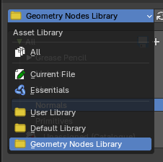
Library Contents
To select the Default Library, choose it from drop-down box that contains the libraries that comes with Bforartists. Here you can select what asset you want to load. You also have a Geometry Nodes Library.
The assets are grouped by categories.

Categories
- Collections
  - Lights
  - Static Meshes
    - Backgrounds
    - Utility
- Materials
  - Ceramic
  - Cloth
  - Foilage
  - Glass
  - Liquids
  - Metals
  - Misc
  - Paint
  - Plastic
  - Rubber
  - Templates
  - Utility
  - Wood
- Shader nodegroups
  - Color
  - Layers
  - Mapping
  - Masks
  - Patterns
  - Shaders
  - Shapes
  - Utility
- Geometry Nodes
  - Grease Pencil
    - Operations
    - Read
    - Write
  - Material
  - Mesh
  - Normals
  - Primitives

Simple Usage

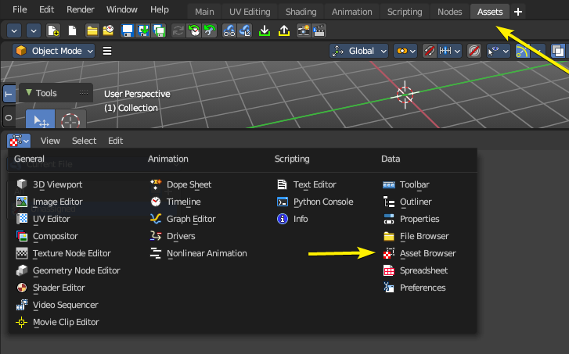
Preparation
Select the Assets Workspace or alternatively change and editor by toggling the Hide Editor Type and changing it to the Asset Browser.
Once you have an asset browser open, select the Default Library from the drop down to the top left of the editor.

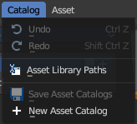

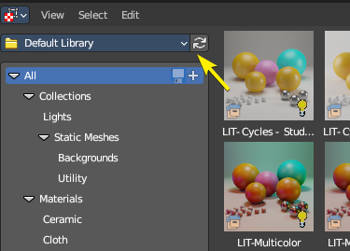

If you don’t see any assets, press the refresh icon.

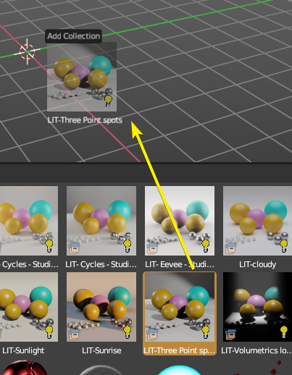
Loading Assets
Click on any categories in the left sidebar, then click and drag on an item to then add it into either the Node editors or the 3D View.
The asset and editor context may influence where you can drag and drop. Example: A collection can only be added to the 3D Viewport, but a Node Group can only be added to the Node Editor in the correct mode (Shader, Geometry Nodes, etc)
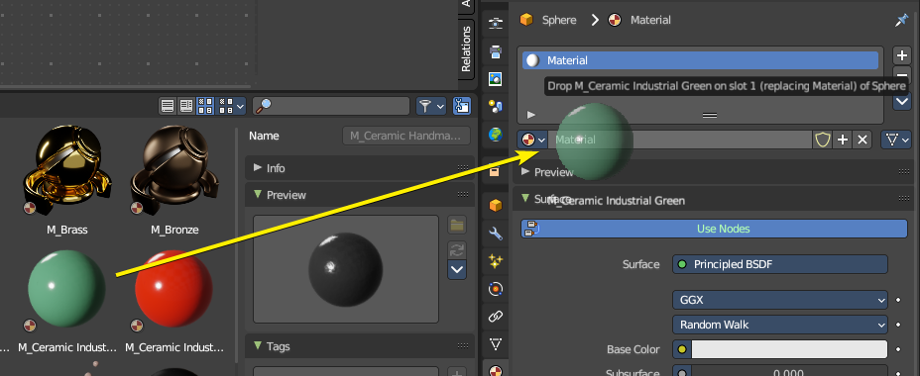
You can also drag and drop the assets onto data slots.

Preferences

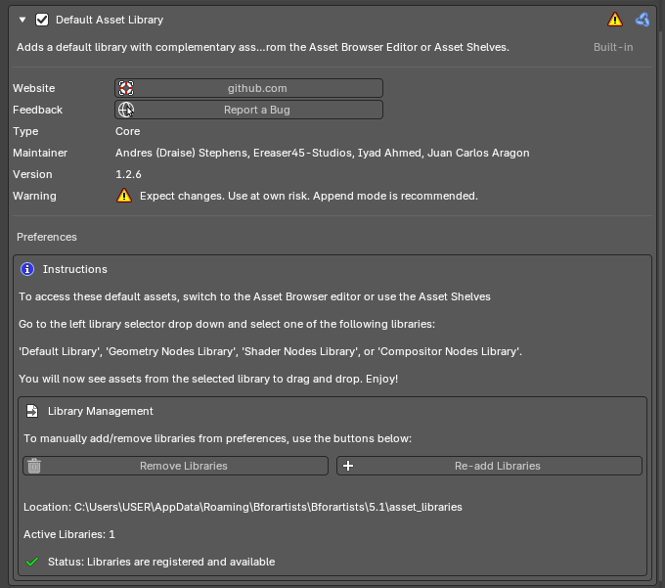
The Default Asset Library is an addon which comes with various functions like modular library management, additional operators and wizards and extended asset interfacing.
When you enable the addon, it will copy the asset library to a central library location.
Note: Bforartists ships with one asset library addon, but you can get support the project by purchasing individual asset library addons available from the Trinumedia sponsor.

Instructions
This is a note on where to find the libraries, how to use them and what they are called.

Library Management
Contains operators to manually add/remove libraries from preferences.

Remove Libraries
Removes the addon libraries to the central library. If there are no other library addons used, this will remove all library files.

Re-add Libraries
Re-adds the addon libraries to the central library.

Library Information

Location
Shows the path of the central library.

Active Libraries
Shows how many addon libraries are used.

Status
Shows if the addon library is registered and available.

Wizards

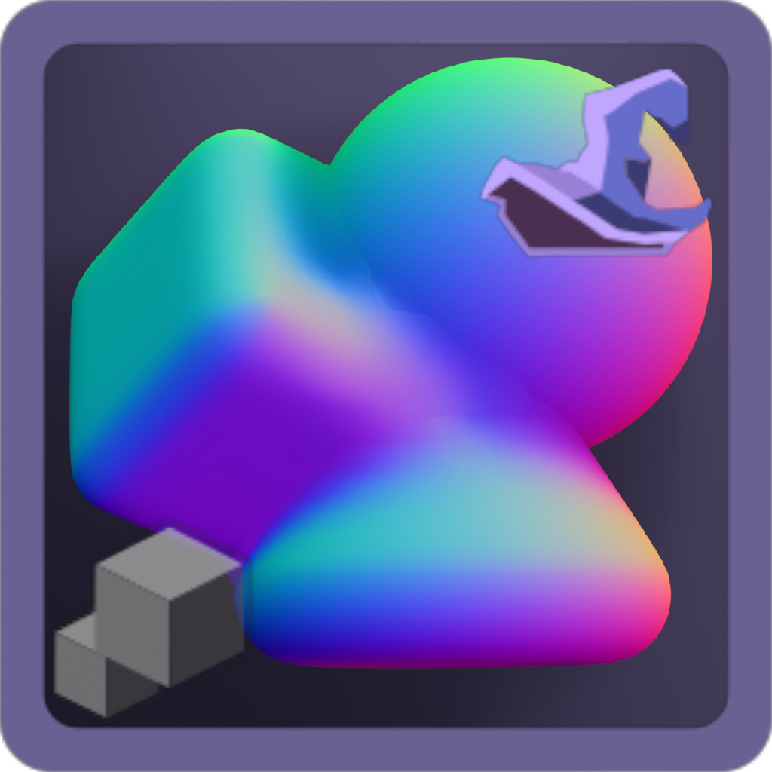
Triggering the Wizard
Smart assets contain a “Wizard” to help set the asset up. When you drag in an asset with a Wizard hat icon, this means the asset has a wizard enabled. After adding the Smart asset, the Wizard will popup a setup panel to help adjust quick settings to get the advanced asset running.
This wizard can also be used to run and re-run operations to ease the use of the asset.
Note: You can only trigger a wizard on a wizard enabled asset added or linked and overriden in the scene.

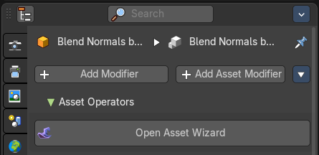
To re-trigger the wizard, you can go to the 3D View – Sidebar – Item tab – Asset Properties panel and run the “Open Asset Wizard” or use the Asset Operators in the asset modifier stack.

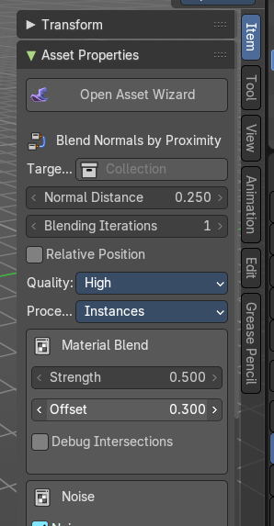

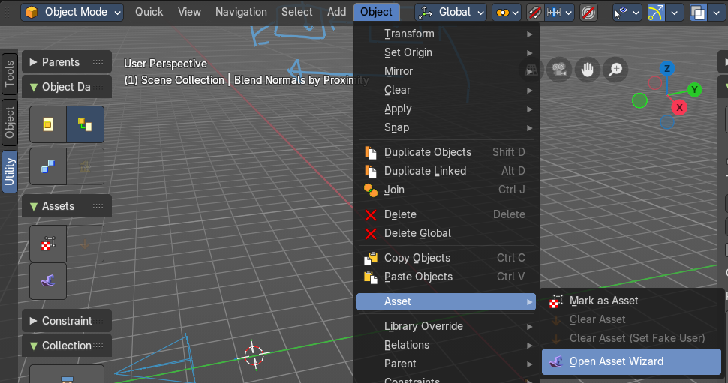
You can also go to the 3D View - Header – Object – Assets – Open Asset Wizard or use the Sidebar to re-trigger the asset.

Using the Sidebar to change asset properties
You can adjust Geometry Nodes Asset Modifier settings and common properties through slider properties and check boxes directly from the 3D View in the Sidebar.
You can modify numerical inputs for quick parameter changes by size, distance or angle.
Access these properties from the 3D View sidebar in the Item tab, in the Primitive Properties panel.
Note: This panel will only enable for specific assets like Primitives or Blend mesh by Proximity

Open Asset Wizard
This will re-trigger the wizard for the selected asset.

Modifier Name
The selected asset name.

Modifier Properties
These are the asset properties also found in the Properties Editor in the Modifier stack.

Default Library

Collections - Lights
Here you can get an overview how the result looks like for the different lighting set-ups. Note that just the Cycles results are showing here.
Be careful with the volumetrics examples. Especially the Musgrave example can render eons.
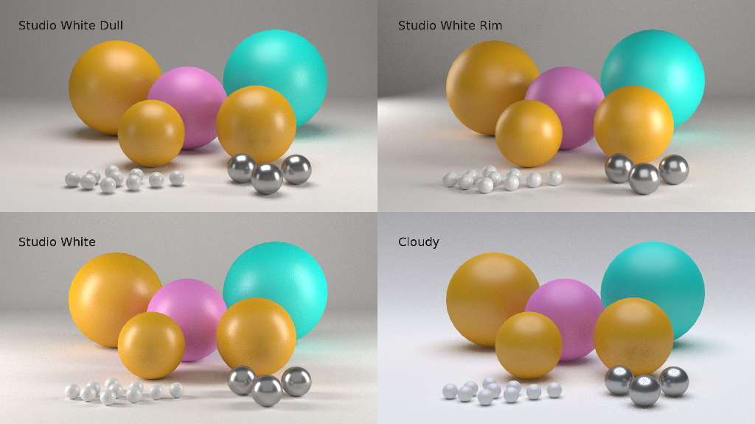
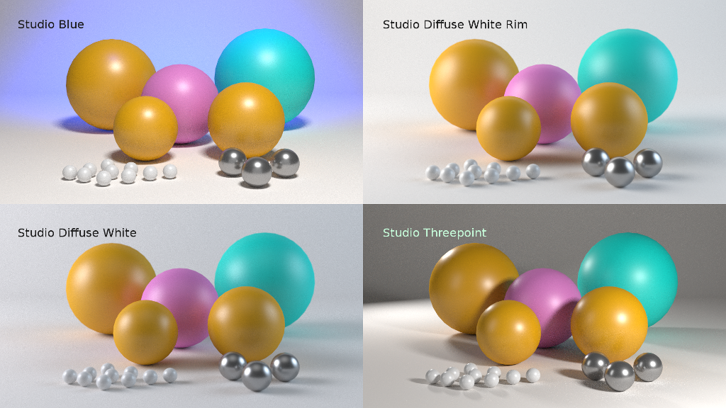
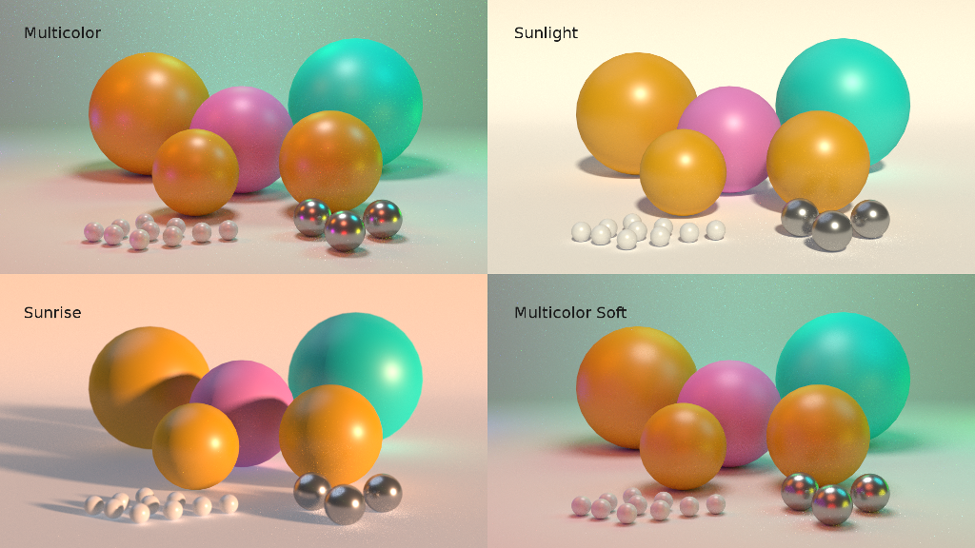
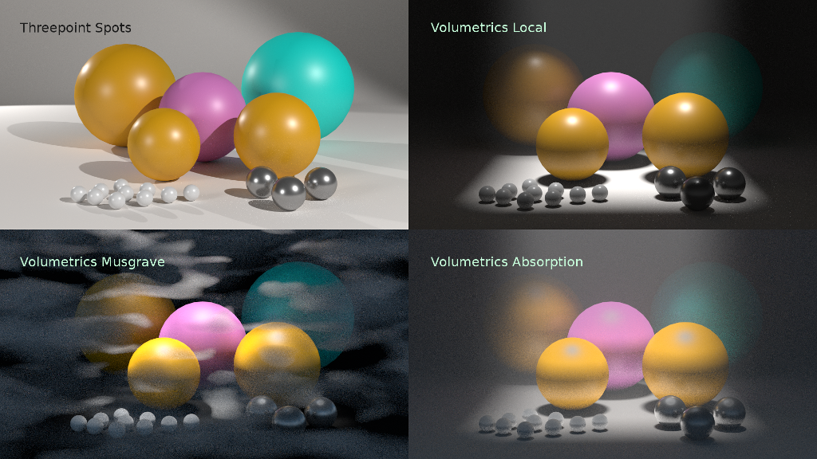

Collections – Static Meshes
This category contains static meshes with the prefix “SM_”, which are collections with objects and materials to be used in various situations.

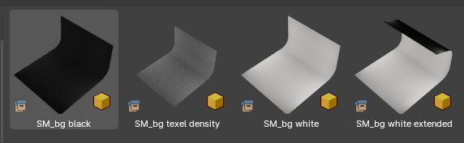
Backgrounds
This category contains quick photographic backdrops.

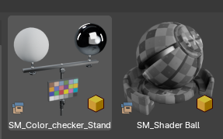
Utility
This category contains utility meshes for object scale, lighting and others, including a shader ball.

Curve
These are Geometry Nodes nodegroups for Curve and Curves objects.

Grease Pencil
This category contains Geometry Nodes nodegroups for Grease Pencil Objects, you can find them in the Geometry Nodes Add Curve menu.

Materials
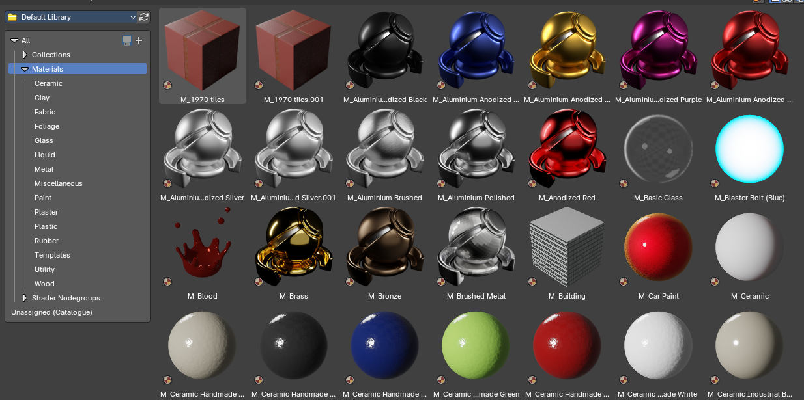
This category contains materials useful to quickly apply materials to your objects via drag and drop. You can then later modify the materials in the Properties Editor Materials tab or in the Shader Editor.

Ceramic
Procedural ceramic materials

Clay
Procedural ceramic materials

Fabric
Procedural fabric materials

Foliage
Foilage materials

Glass
Procedural glass materials

Liquid
Procedural liquid materials

Metal
Procedural metal materials

Miscellaneous
Various materials for miscellaneous use cases

Paint
Procedural paint materials

Plaster
Procedural plaster materials

Plastic
Procedural plastic materials

Rubber
Procedural rubber materials

Templates
Material templates to help setup various material setups

Utility
Varopis utility materials

Wood
Procedural wood materials

Shader Nodegroups
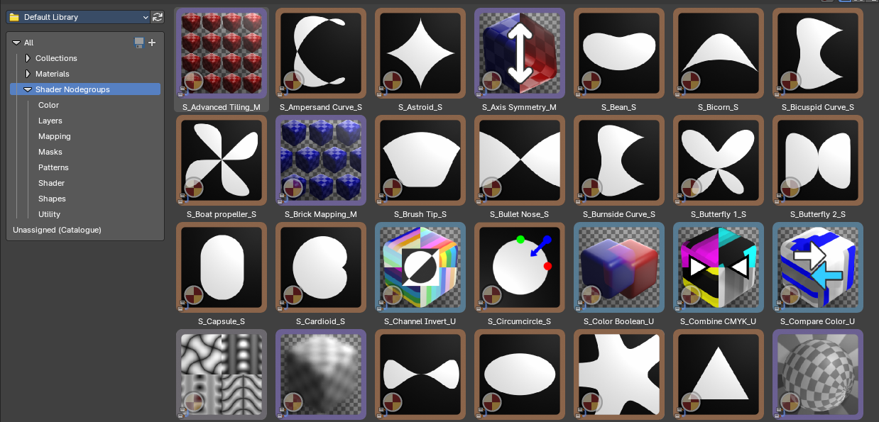
This category contains shader nodegroups useful to create procedural materials in the Shader Editor.

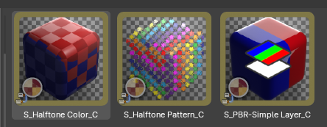
Color
These nodegroups are used to define color halftone effects or a simple PBR layer mix node.

(Vector) Mapping
These nodegroups are used as vector UV mapping nodes to define vector interactions from various texture projections types, from tiling to deformations.
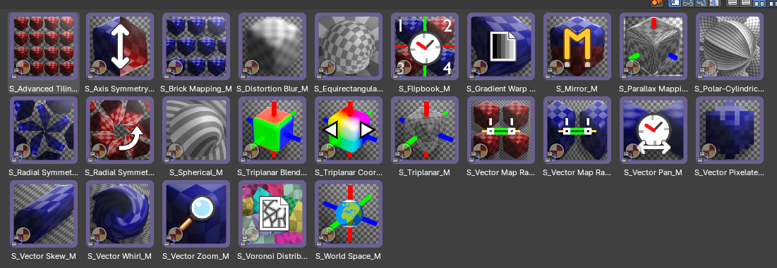

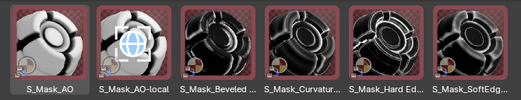
Masks
These nodegroups are useful to create masks for edgewear and other effects when layering materials or textures.
Most of these edge masks nodes work exclusively with Cycles, though one works with Eevee. They also contain edge noise, edge breakup and ambient occlusion masking for more control.
They work best when you bake the results as a texture mask to your meshes that have been unwrapped.

Patterns
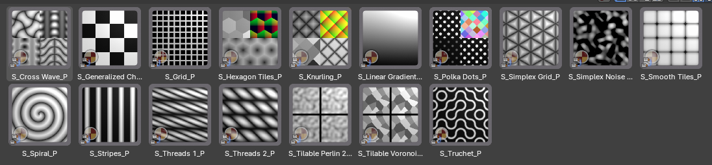
These nodegroups are useful to create procedural patterns for masks or textures in your materials. Each comes with their own set of parameters and data outputs, from UVs, tile position, random color, random values and more.

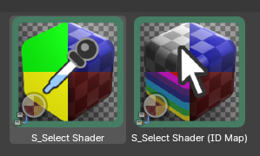
Shader
These nodegroups are useful to select shaders via ID or color switches.

Shapes
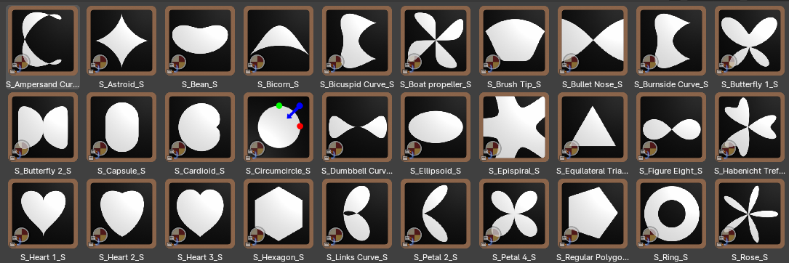
These nodegroups are procedural shapes that you can use with a combination of mapping and pattern nodegroups to then create masks or new patterns. Useful for creating new textures, brushes and motion graphics.

Utility
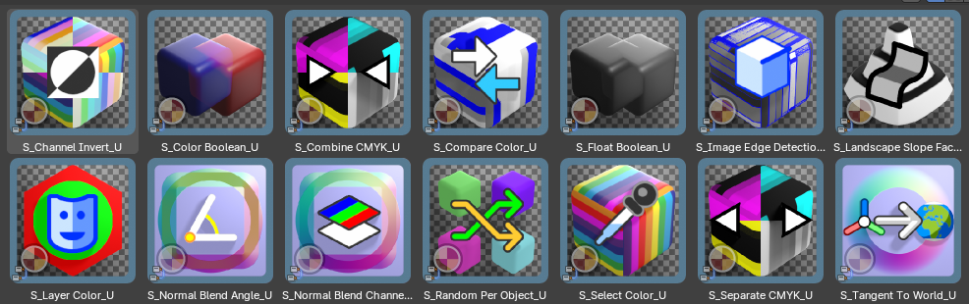
These nodegroups are useful to assist various miscellaneous tasks with shader nodes from normals, colour and masks.

Geometry Nodes Library

Grease Pencil

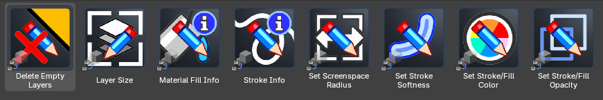
Operations

Delete Empty Layers
Removes all grease pencil layers that contain no strokes or data—helps performance.
Note: This is only available for the Node Editor asset shelf.

Read

Layer Size
Displays the resolution or size setting of selected grease pencil layers.
Note: This is only available for the Node Editor asset shelf.
Reveals fill material details for strokes in the selected grease pencil object.

Material Fill info
Note: This is only available for the Node Editor asset shelf.

Shows stroke-related grease pencil information. Ideal for optimization or debugging.

Stroke Info
Note: This is only available for the Node Editor asset shelf.

Write
Applies a consistent stroke thickness based on screen space (rather than object scale), helping ensure visual uniformity regardless of zoom or resolution. This depends on the Camera View.

Set Screenspace Radius
Note: Available for the Node Editor and 3D View asset shelf as a modifier.

Controls edge softness or blending falloff of strokes. Enables more painterly or smooth transitions.

Set Stroke Softness
Note: Available for the Node Editor and 3D View asset shelf as a modifier.

Applies predefined color values to both stroke and fill channels of selected grease pencil elements.

Set Stroke/Fill Color
Note: Available for the Node Editor and 3D View asset shelf as a modifier.

Adjusts transparency levels for stroke and fill independently. Useful for layering and compositing effects.

Set Stroke/Fill Opacity
Note: Available for the Node Editor and 3D View asset shelf as a modifier.

Materials

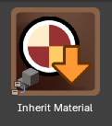
Inherit Material
This uses the material in the Material tab of the Properties editor as a Geometry Nodes material override.
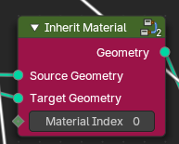
This utility transfers the first material slot from an assigned material from the parent object that holds the Geometry Nodes modifier object to the Geometry Nodes procedural geometry. It’s especially useful in workflows where instanced or procedural generated geometry needs to adopt top level material settings through top level manual assignment.

Source Geometry
The source object material, typically the top level geometry of the parent object.

Target Geometry
The procedural geometry to pass the material to.

Material Index
Selects the material slot index.

Mesh

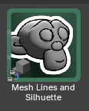
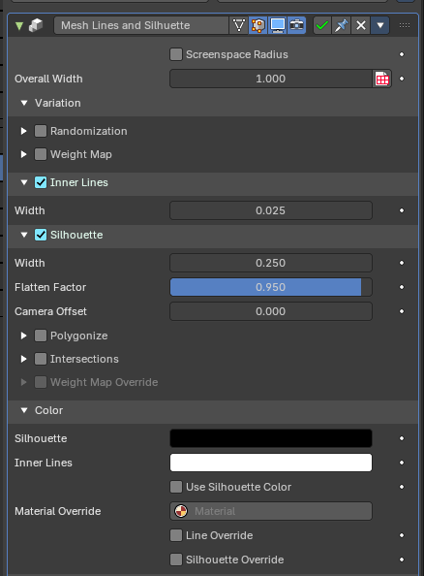
Mesh Lines and Silhouette
Note: Available for the Node Editor and 3D View asset shelf as a modifier.

Screenspace Radius
When enabled, line thickness is adjusted based on screen space, ensuring consistent appearance regardless of distance or object scale. This is based on the camera view only.

Overall Width
Controls both the silhouette and lines width with a general size control.

Variation

Randomization
Introduces procedural noise into line generation for organic or sketchy effects.

Factor
Intensity of variation.

Scale / Detail / Lacunarity / Distortion / Roughness
Fine-tunes the procedural noise characteristics.

Weight Map
Customizes variation intensity via a vertex group.

Vertex Group
Name of influencing vertex group

Offset
Shifts the vertex group weight and offsets the width of the inverse hull lines

Inner Lines
Adds an inverse hull mesh to simulate lines across surface features to emphasize internal geometry.

Width
Controls thickness of inner lines.

Silhouette
Highlights mesh contours by drawing a backdrop mesh that has been flattened behind the camera angle. This creates a silhouette line or mesh. This is based on the camera view only.

Width
Sets the silhouette line thickness.

Flatten Factor
Compresses and flattens the silhouette backdrop shape. Less values returns the backdrop silhouette mesh to a 3D shape.

Camera Offset
Shifts silhouette backdrop mesh closer or further away from the camera relative to the object position.

Polygonize
Enables silhouette line segmentation based on surface polygons by welding geometry by distance.

Factor
Controls degree of welding influence for polygonization.

Intersections
Adds silhouette strokes where geometry intersects or overlaps.

Width Offest
Sets the silhouette intersection line thickness.

Object
Selects the intersection object to draw lines

Use a Collection
Defines if the intersection should be defined by a collection

Collection
Selects the intersection collection to draw lines

Weight Map Override
Applies custom width influence from a vertex groups. To use, select an existing vertex group to use, then use the Weight Paint mode to paint. Weight of 1.0 is maximum influence that displaces the width of the inverse hull lines or silhouette, and weight of 0.0 is minimum influence.

Factor
Strength of the effect of the weight map.

Color

Silhouette Color
Sets color for silhouette backdrop mesh.

Inner Lines Color
Sets color for inner lines.

Use Silhouette Color
Forces internal lines to inherit silhouette color.

Material Override
Defines a custom material for material overrides.

Line Override
Applies material override to the inner mesh lines.

Silhouette Override
Applies override specifically to the silhouette backdrop mesh.

Normals

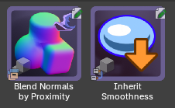

Blend Normals by Proximity
Adds an object that references a collection to merge all children mesh objects with blended normals and materials by proximity, through intersection distance and blur. This also displaces meshes at intersections.
This asset is ideal for smoothing transitions between intersecting surfaces, faking lighting continuity, or unifying shading across modular components.

Use
This contains a setup wizard to begin.
- Drag and drop the asset into the scene
- You will be prompted to select a target collection
- This will then convert the target collection into driver objects with optional bounding visibility, relative position and material blending – then it create a new mesh with blended normals.
- Now you can add new objects to the target collection to influence the new blended normals mesh.
- When you are ready, apply the modifier to remesh, start sculpting or modeling. The normals will remain on the applied mesh.

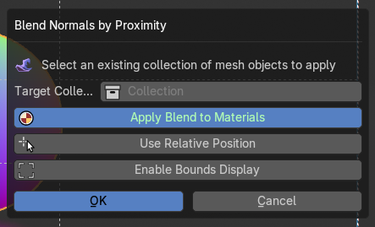
Target Collection
Specifies the collection of the group of objects used to influence the normal blending.

Apply Blend to Materials
This applies an intersection gradient alpha to the target collection objects. This will iterate through all objects and materials and applies the alpha at the intersection.
Note: If you add new materials or objects to the target collection, re-running the wizard will re-apply.
If you turn it off and reapply the wizard, it will remove the material blend from all materials and objects in the target collection.

Use Relative Position
This will enable the relative position of the source target collection objects, making the new blended mesh snap to the original position. If you keep this off, the new blended mesh will spawn or move to it’s asset placement position.

Enable Bounds Display
This will turn on Bounds display for all the objects in the target collection, useful to remove any z-fighting normals when using a Relative Position on the new blended normals mesh object.
Note: If you add new objects to the target collection, re-running the wizard will re-apply the visibility settings on the new objects.
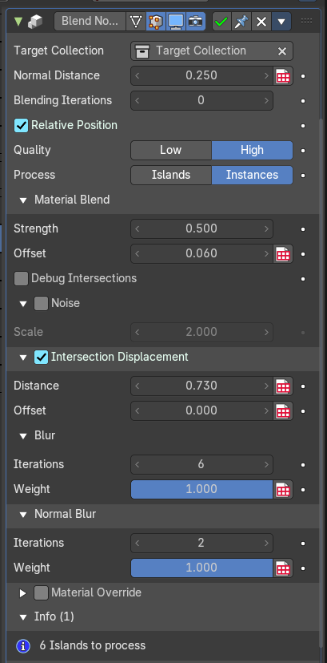
If you turn it off and reapply the wizard, it will remove the Bounds display from all objects in the target collection.

Modifier Properties

Target Collection
Specifies the group of objects used to influence the normal blending.

Normal Distance
Sets the range within which intersecting geometry will contribute to the normal blending by proximity process.

Blending Iterations
Adds another blending iteration to the group of objects to assist in solving self-intersecting blending issues. This will affect performance as this repeats the operation.

When enabled, calculates blending based on object-relative coordinates. Useful for maintaining orientation consistency with source objects from the target collection.

Relative Position

Quality
This defines the quality of the normal blending which affects performance.
- High: Uses blending by proximity. Default. This can be low on performance if there are many islands or instances being evaluated.
- Low: Uses a “nuetral” normal at the intersections. This is more performant but less noticeable.

Material Blend

Strength
Controls how strongly materials are blended at the intersections.

Offset
Shifts the blend region inward or outward from the intersection. Fine-tunes where the material transition begins.

Debug Intersections
Visualizes intersection zones for troubleshooting. Helpful for verifying blend boundaries or for using it to bake to a new texture.

Noise
Adds procedural noise to the blend region. Useful for organic or stylized transitions.

Scale
Controls the scale of the noise pattern. Higher values produce larger, more visible noise features.

Intersection Displacement
Enables geometry displacement at intersection zones. Controls how intersection regions between meshes are offset and displaced before normal blending. Used to create bulges, dents, or organic merging effects

Distance
The threshold for detecting intersections. This defines how far the geometry is displaced from its original surface.

Offset
Shifts the displacement region relative to the intersection. Moves vertices slightly to resolve overlap artifacts.

Blur
Softens the influence of blended normals across adjacent geometry

Iterations
Number of smoothing passes on the displacement.

Weight
Intensity of smoothing. Higher values lead to broader averaging.

Normal Blur
Optional secondary blur targeting only normals.
Note: This only blurs normals at the intersections. Object normals are preserved.

Iterations
Number of blur passes applied to normals.

Weight
Strength of normals blur smoothing.

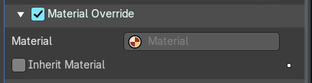
Material Override
Toggles material overrides, otherwise it will inherit each objects from the target collections' material.

Material
Selects the material for the material override.

Inherit Material
This toggles the use of the material in the Material tab of the Properties editor as the override.

Info
Displays how many mesh islands are currently being blended. Useful for performance monitoring and debugging.

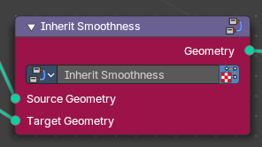
Inherit Smoothness
This utility transfers the smoothness (normals) of the parent object that holds the Geometry Nodes modifier object to the Geometry Nodes procedural geometry. It’s especially useful in workflows where instanced or procedural generated geometry needs to adopt top level smoothness settings through top level manual assignment.

Source Geometry
The source object smoothness, typically the top level geometry of the parent object.

Target Geometry
The procedural geometry to pass the smoothness to.

Primitives
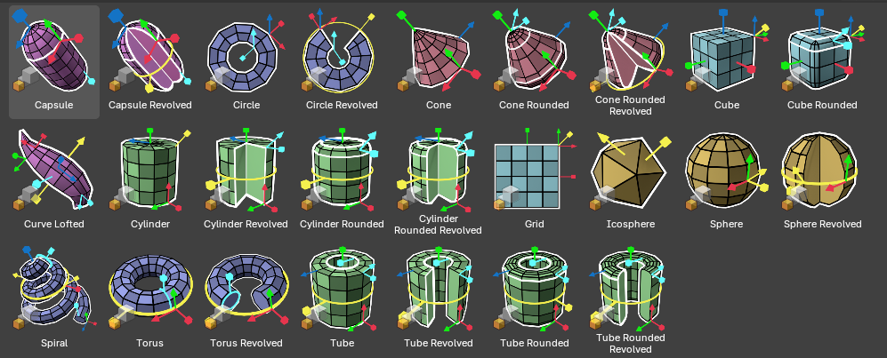
These smart primitives are procedural shapes with gizmos to control width, height, resolution, radius, revolutions angles, and other settings including bevel, bevel resolution and other controls.

Use

Using the Gizmos
When the modifier is selected, you can use gizmos directly in the viewport to adjust values of the primitives in an intuitive sense. They are color coded to specific functions.
Red/Green/Blue Square is XYZ scale respectively
Red/Green/Blue Arrow is XYZ loop resolution respectively
Primary Yellow
Circle: Revolve Angle
Square: Scale all axis’
Arrow: Adjust all loop resolutions
Secondary Cyan
Arrow: Bevel Resolution
Square: Bevel Scale
Circle: Twist

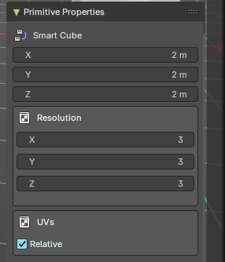
Using the Sidebar and Modifier properties

Top-Level Properties
Adjust settings affecting all primitives with common properties through slider properties and check boxes
Modify numerical inputs for quick parameter changes by size, distance or angle.
Access these properties from the 3D View sidebar in the Item tab, in the Primitive Properties panel.

Bevel Properties
Set bevel depth and resolution.

Resolution Properties
Modify loop resolution
Set subdivision detail

UV Properties
Enable relative scale UV's, when applicable
Modify UV scaling and alignment (Coming soon)
Modify UV type, relative or absolute (In Progress)

Basic Shapes

Cube
A standard six-sided shape, great for solid modeling. Includes relative Uvs and resolution gizmos.

Cube Rounded
A cube with softened edges for a more organic feel.

Sphere
A perfect round primitive, ideal for smooth surfaces. Includes relative resolution controls.

Icosphere
A low-poly spherical shape made of triangles, great for optimization with various levels of resolution.

Cone
A tapered shape with a circular base, useful for pointed structures.

Cone Rounded
A cone with a smoother, more organic tip.

Cylinder
A uniform circular primitive, essential for pipes and tubes.

Cylinder Rounded
A cylinder with softened edges for better transitions.

Tube
A hollow cylindrical primitive, great for mechanical parts.

Tube Rounded
A tube with smooth edges for a more natural look.

Advanced Forms

Capsule
A stretched sphere useful for stylized characters and smooth objects.

Capsule Revolved
A capsule rotated for unique geometry shaping. Includes the abilty to revolve around an angle.

Grid
A flat subdivided plane useful for ground surfaces and mesh guides. Includes relative Uvs.

Torus
A ring-shaped primitive, ideal for looped structures.

Torus Revolved
A torus rotated for specialized forms. Includes the abilty to revolve around an angle.

Spiral
A coiled shape, useful for decorative and mechanical designs.

Circle
A simple 2D shape for base geometry and cutouts. Includes stamped or path based UV's.

Circle Revolved
A circular shape rotated into a 3D form. Includes the abilty to revolve around an angle.

Curve Lofted
Generates complex surfaces using loftes curves with a central profile gizmo system. Includes taper, bend, swell and volume bevel controls.

Cylinder Revolved
A cylindrical shape rotated for varied effects. Includes the abilty to revolve around an angle.

Cylinder Rounded Revolved
A rounded cylinder adapted for more curvature. Includes the abilty to revolve around an angle.

Tube Revolved
A tube rotated for improved modeling flexibility. Includes the abilty to revolve around an angle.

Tube Rounded Revolved
A smoothed, rotated tube for streamlined designs. Includes the abilty to revolve around an angle.

Cone Rounded Revolved
A tapered primitive that blends sharpness with curvature. Includes the abilty to revolve around an angle.

Sphere Revolved
A sphere adjusted through rotation for unique formations. Includes the abilty to revolve around an angle.

